***Extra! Extra!***

***Read All About Class 3-322D!***

***October 2023***

MC900442030[1]

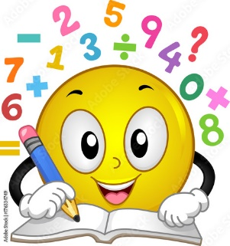**Math**

We are currently practicing and understanding our first topic, “Using Strategies and Properties to Add and Subtract”. We are learning properties of addition and rounding whole numbers to the nearest 10 and 100 by using place value and a number line, estimating sums, and solving multi-step word problem.



**Writing**

We have written our autobiographies and introduced ourselves to our peers. We are currently writing personal narratives.

**Reading**

Over the course of the next few weeks, we will focus on reading realistic fiction. We will continue to build our knowledge about literary elements (characters, setting, plot, event), the narrator’s point of view, make and confirm predictions, identifying the theme of a text, and understanding figurative language.

The characters in this genre, realistic fiction demonstrate their uniqueness and show how they are true to themselves when faced with many challenges.



* Complete Parent Survey:
* Please join our google classroom.
* Check your child’s homework folder/notebooks for important notices and sign homework.
* Read with your child for 30 minutes, ask questions about the story, and fill in the reading log.
* Log on to i-Ready every night and complete 1 lesson in math and 1 lesson in reading.